**OOPS:**

**Class and Object:**

Class is a blueprint for objects. Objects are instances of classes. Classes define attributes and behaviours.

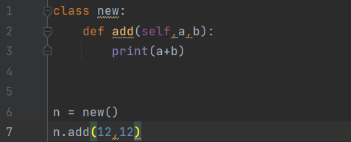

**Output:**



**Access Specifiers:**

Python uses naming conventions for access control.

**PUBLIC:**   
No strict public specifier in Python. By convention, attributes without underscore are considered public. Encourages transparency and collaboration.

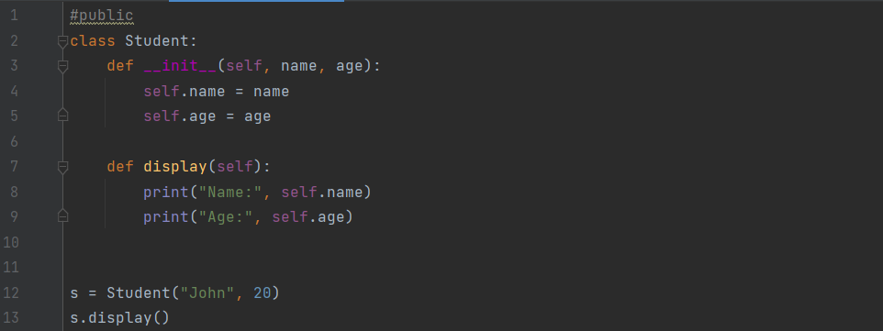

**Output:**



**PRIVATE:**

Attributes prefixed with double underscores (‘__’) are considered private. Access restricted to the defining class. Encourages encapsulation and data hiding.

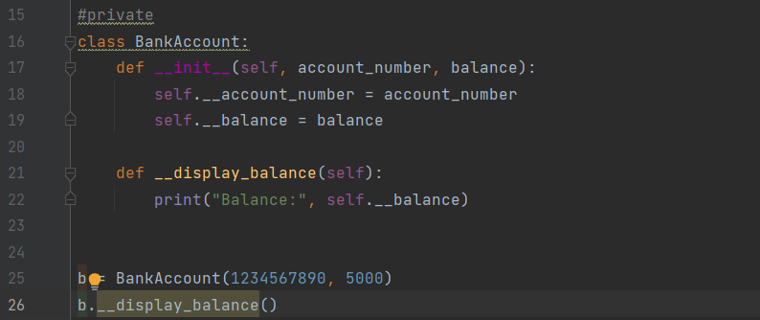

**Output:**

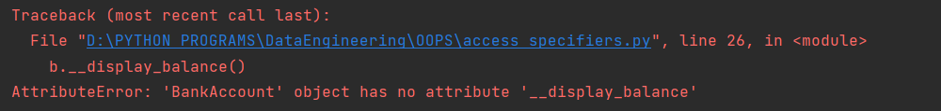

**PROTECTED:**

Attributes prefixed with a single underscore (‘_’) are considered protected. Conveys a hint that the attribute is for internal use.

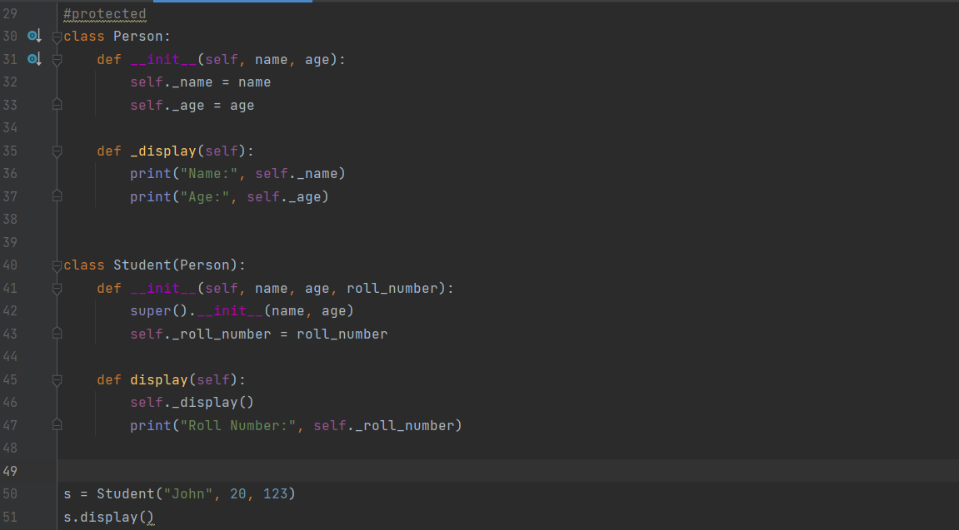

**Output:**

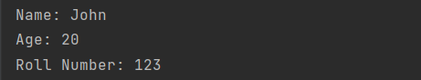

**Constructor:**  
Special method __init__ in classes. Initializes object attributes. Automatically called when an object is created.

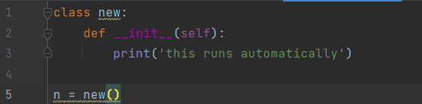

**Output:**



**Inheritance:**

Mechanism where a class inherits properties and methods from another. Encourages code reuse.

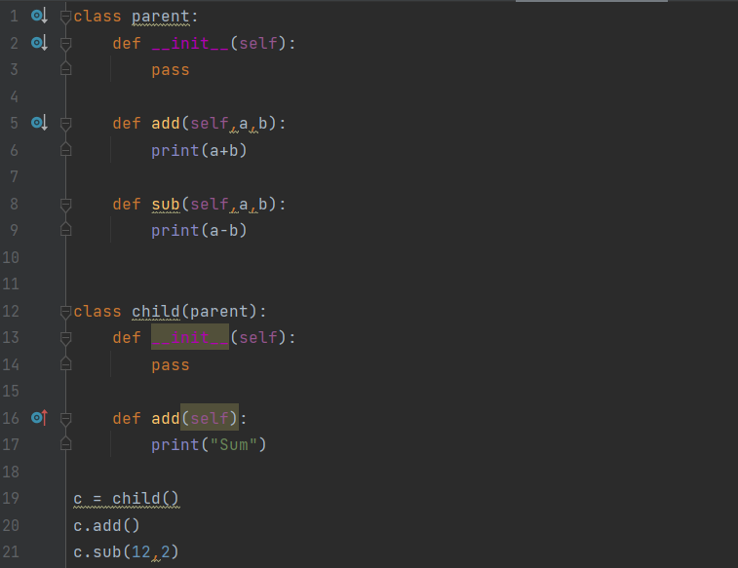

**Output:**

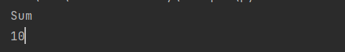

**Polymorphism:**

Ability to use a single interface for different types. Objects of different classes can be used interchangeably. Enhances flexibility.

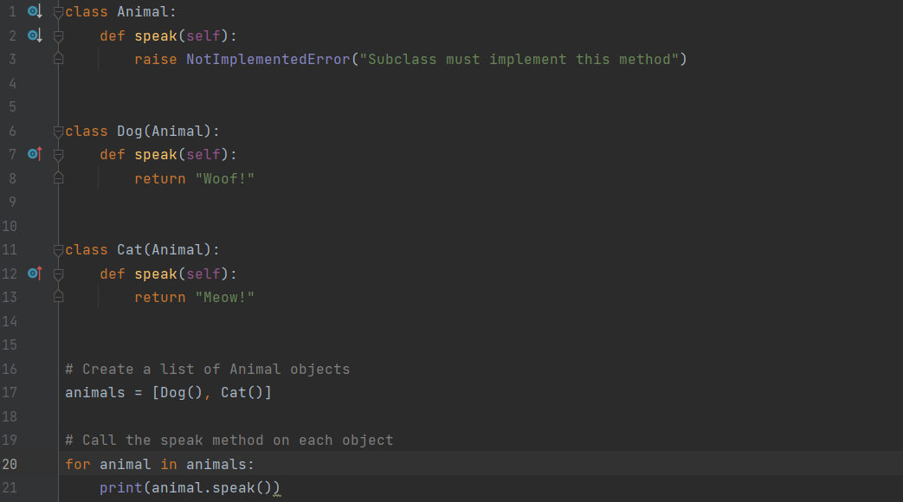

**Output:**



**Method Overriding:**  
Inheritance feature. Child class redefines a method of its parent class. Provides a specific implementation in the child class.

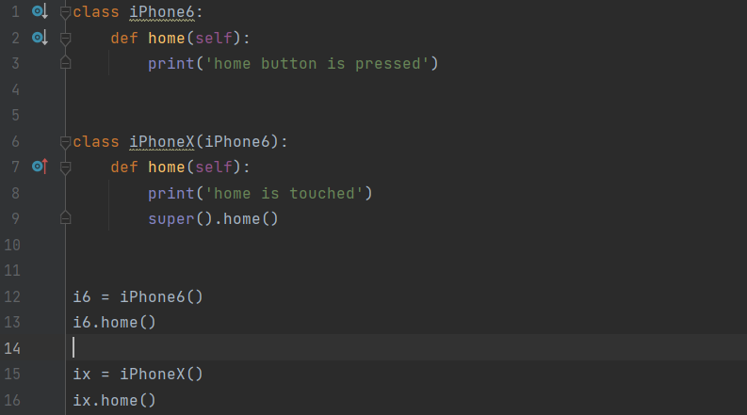

**Output:**

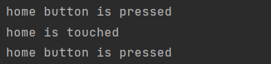

**File Handling:**  
Reading/writing files. Open, read, write, close. Modes: read ('r'), write ('w'), append ('a').

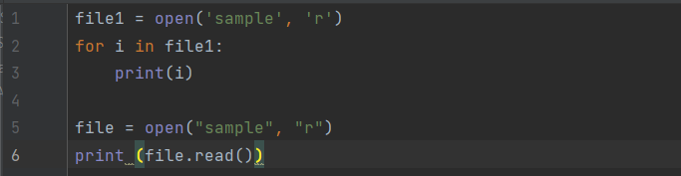

**Output:**



**Exception handling:**

Handling errors during program execution. Try block contains code. Except block catches exceptions. Finally block executes regardless.

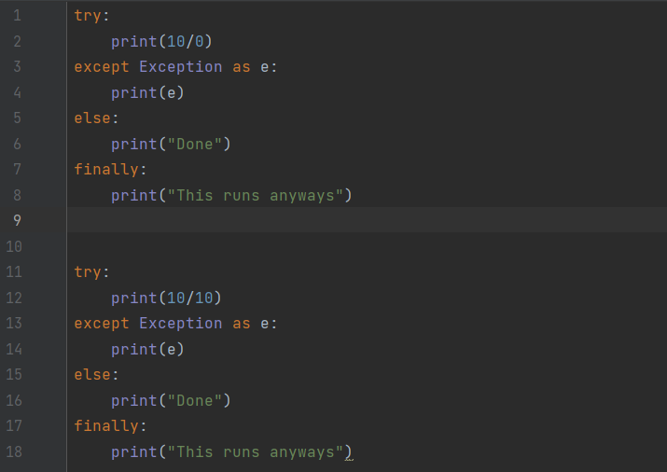

**Output:**

